EXPERIMENT-08
Aim: To develop an Android application that uses Alert Dialog, Date Picker, and Time Picker and handles user interaction.
Theory:
Android provides UI components like AlertDialog, DatePickerDialog, and TimePickerDialog to interact with users. These components help in taking decisions (dialog), selecting dates, and selecting time through user-friendly interfaces.
Android provides interactive UI components like AlertDialog, DatePickerDialog, and TimePickerDialog to enhance user interaction.
- AlertDialog is used to display messages and get user confirmation through buttons like Yes or No.
- DatePickerDialog allows users to select a date using a calendar interface.
- TimePickerDialog enables users to choose time (hour and minute) using a clock interface.
These components help in collecting user input in a simple, structured, and user-friendly way.
- Design Layout
  - Open activity_main.xml
● Add:
    - Button → Show Dialog
○ Button → Select Date
○ Button → Select Time
○ TextView → Display result
- Implement MainActivity
  - Initialize views using findViewById():
    - Buttons and TextView
- Alert Dialog Implementation
  - Use AlertDialog.Builder
● Set:
    - Title → "Confirmation"
○ Message → "Do you want to continue?"
● Add buttons:
○ Yes → show Toast
○ No → show Toast
  - Call show()

- Date Picker Implementation
  - Use Calendar to get current date
  - Create DatePickerDialog
● On selection:

    - Get day, month, year
○ Display in TextView
- Time Picker Implementation
  - Use Calendar to get current time
  - Create TimePickerDialog
  - On selection:
    - Get hour and minute
○ Display in TextView
- Run Application
  - Click buttons:
    - Dialog → shows confirmation
○ Date → opens calendar
○ Time → opens clock
Code:
activity_main.xml
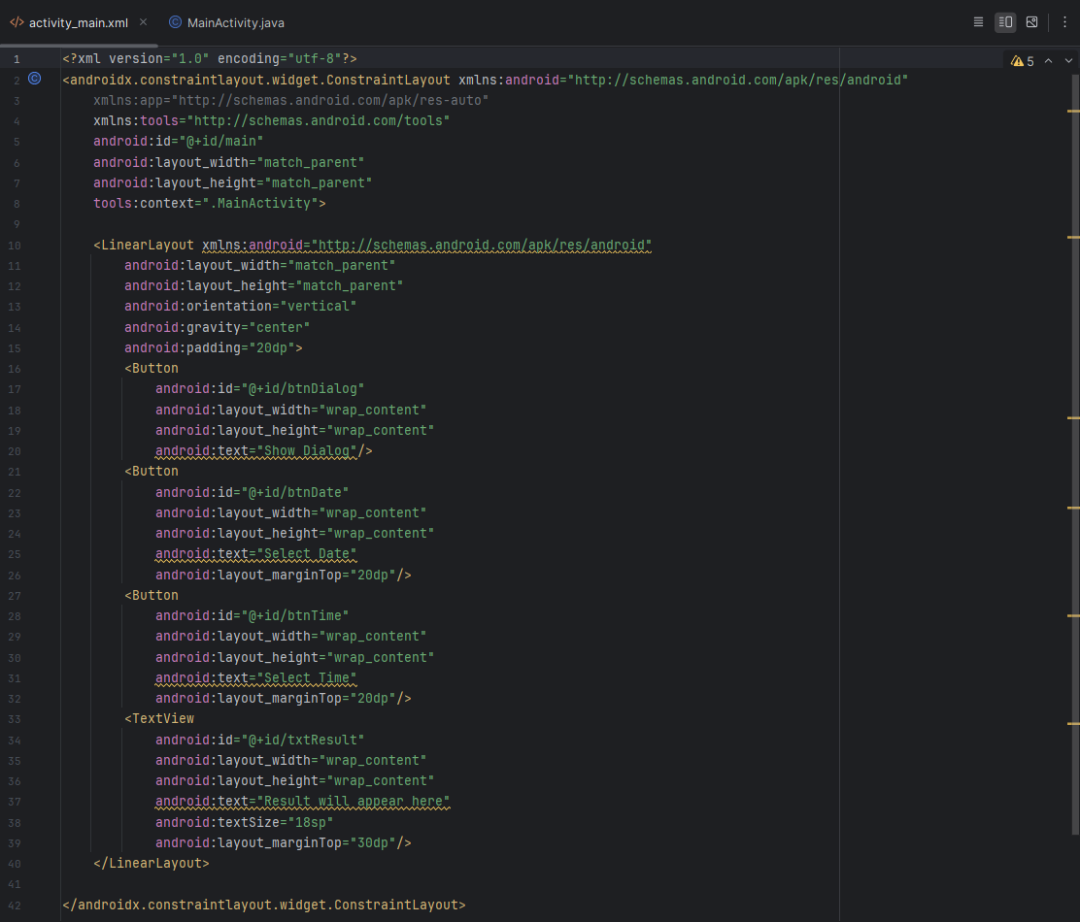
MainActivity.java
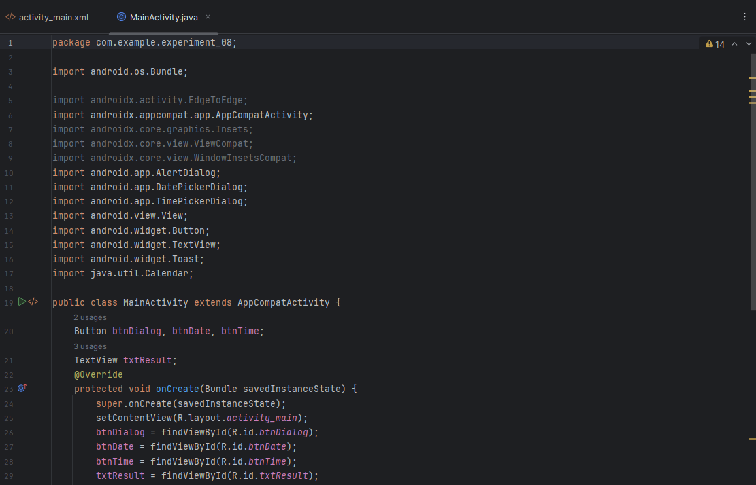
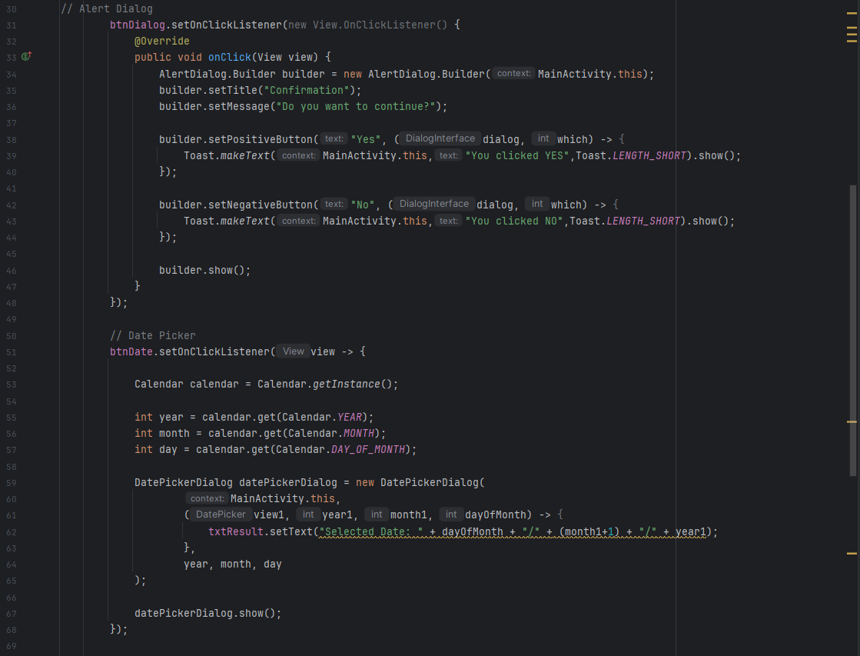
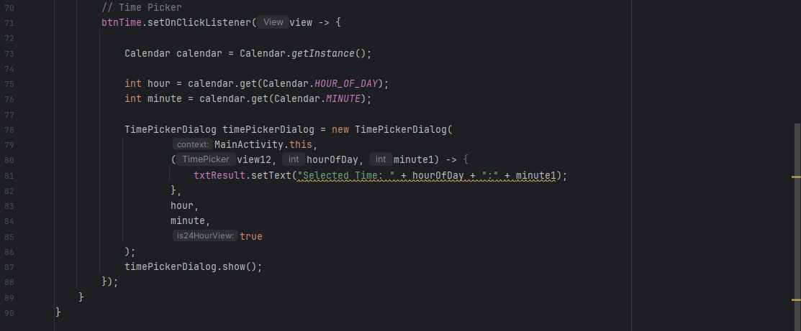

Output:
- Alert Dialog Interaction
  - Displays confirmation message
  - User selects Yes or No
  - Shows Toast response
- Date Selection
  - Opens calendar interface ● User selects date ● Displays:
Selected Date: DD/MM/YYYY
- Time Selection
  - Opens clock interface ● User selects time ● Displays:
Selected Time: HH:MM
●
- Dynamic Output
  - TextView updates based on user actions
- User-Friendly UI
  - Easy interaction using dialogs and pickers

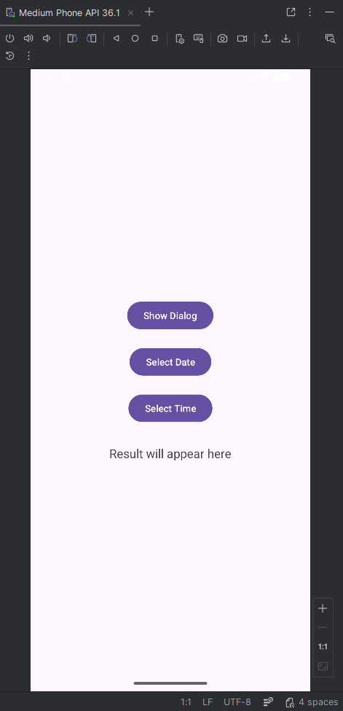 | 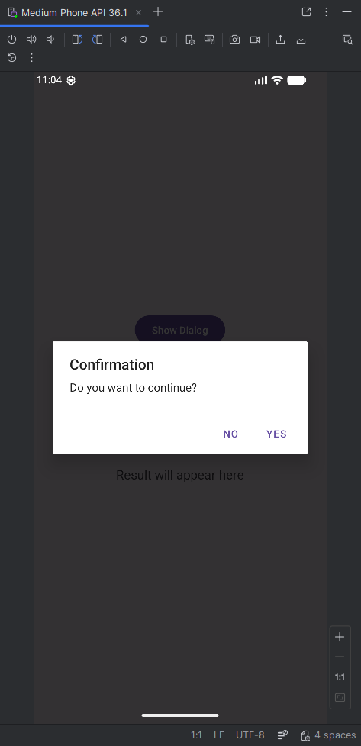 | 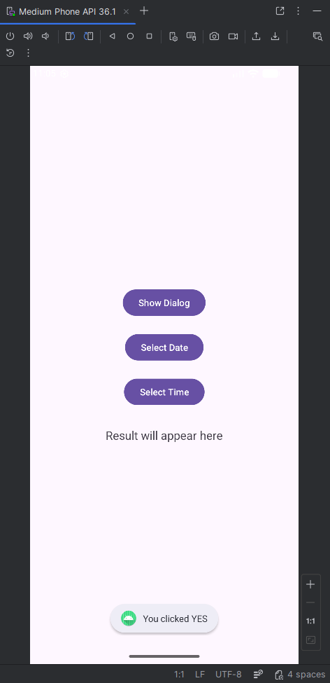

 | 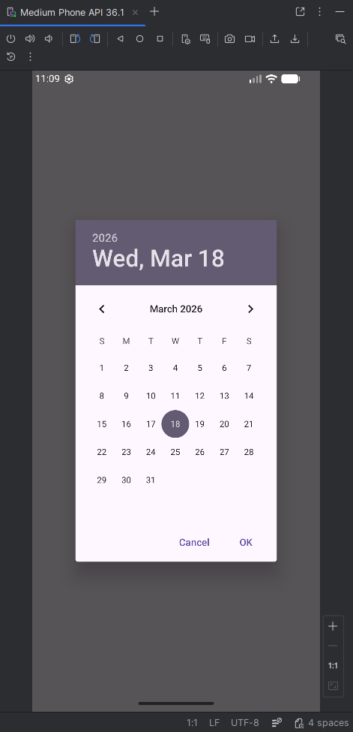 | 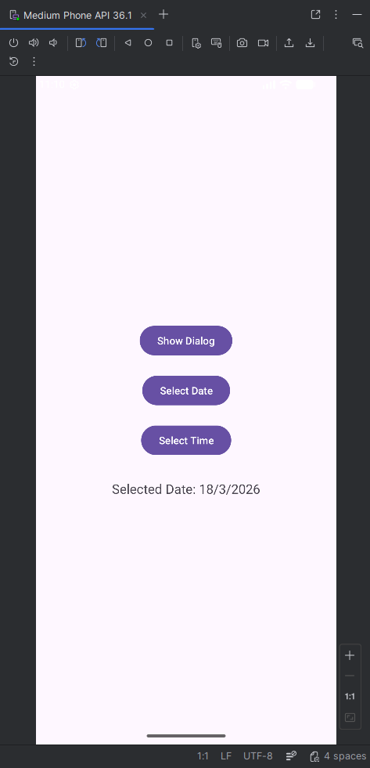
 | 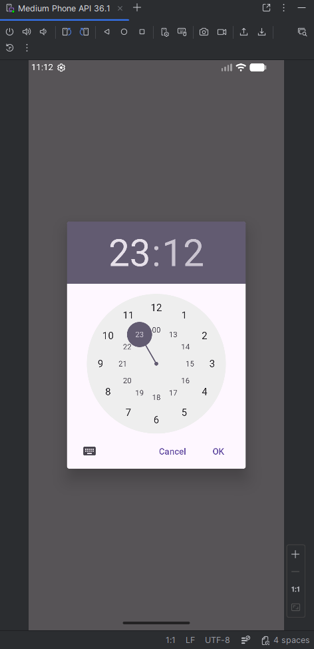 | 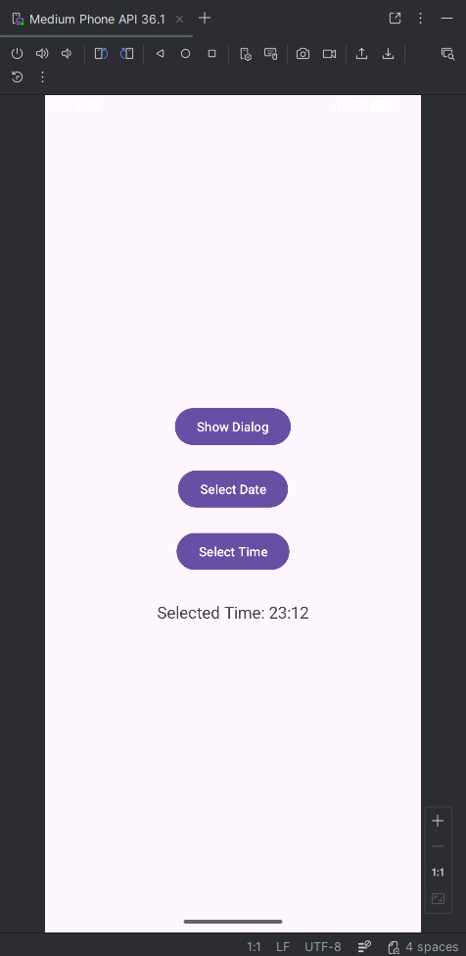

Conclusion:
This practical demonstrates how Android provides interactive components like dialogs and pickers to improve user experience by allowing easy selection of options, dates, and time.

